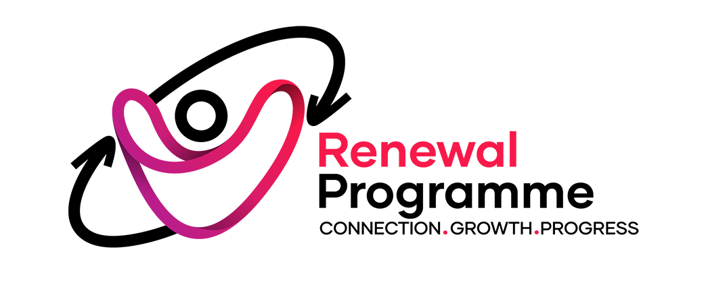

JOB DESCRIPTION

Department: Advice and Support

Job title: Food Sustainability Project Coordinator

Working Hours: 36 hours per week

Rate of pay: £36,934 p/a

Contract: 4-year fixed term, funded by the National Lottery Community Fund.

Reports to: Transformation Hub Manager

Responsible for: Sessional Staff, Project Volunteers.

Location: Mainly our head office in E12, but also in other venues around the borough of Newham as directed.

About the Renewal Programme
For over five decades, the Renewal Programme has been a trusted cornerstone of the community in the London Borough of Newham, tackling the root causes and consequences of poverty, isolation, and disadvantage. We are a well-established and respected local charity dedicated to empowering individuals and communities to reach their full potential. Our holistic approach integrates a wide range of services, including the management of 42 supported housing beds for people at risk of homelessness, advice and support services, adult education and training, youth services, and immigration advice programs. We work with over 3,500 people annually.

Our work is guided by a clear vision of vibrant and integrated Newham communities where everyone has access to suitable jobs, homes, health, and education. We stand alongside those who struggle, inspiring hope and offering opportunities for connection, growth, and progress. This mission is underpinned by our four core values, which are embedded in every aspect of our work:

DIGNITY: Treating everyone with kindness and respect.
INCLUSION: A community where everyone belongs.
COLLABORATION: Working together to achieve more.
EMPOWERMENT: Co-creating opportunities for positive change.

Role overview
This role is central to our mission to support sustainable living, reduce food waste, tackle local food insecurity, and foster meaningful community connections. As a key part of delivering the vision set out in our National Lottery-funded RenewALL Hub proposal, you will ensure our food provision goes beyond meeting immediate needs to build inclusion, wellbeing, and pathways into wider community support.

Your primary responsibility will be to secure regular donations of surplus food by developing and maintaining strong partnerships with local supermarkets, shops, restaurants, and national redistribution organisations like the Newham Food Alliance, Felix Project, and Feeding Britain.

You will manage the effective use of this food across our services, including the foodbank, food pantry, warm meals programme, and cooking classes. This will involve careful stock management, menu planning, and coordinating with lead staff to ensure our food provision meets Newham’s environmental, health, and cultural needs. A key part of this will be overseeing the successful operation and promotion of our expanded food pantry.

Coordinating our dedicated volunteers will be essential, particularly in managing and expanding our cargo bike fleet for surplus food collection and redistribution. You will also explore opportunities to monetise these sustainable transport services. To further engage the community, you will organise and host quarterly workshops on reducing food waste and eating on a budget.

Ultimately, you will play a vital role in coordinating our surplus food operations, managing volunteer teams, and strengthening partnerships to ensure our food services are impactful, sustainable, and community-led.

Detailed role description
1. Food Supply & Partnerships
- Secure regular surplus food donations from local supermarkets, shops, restaurants, farms, and redistribution networks (e.g., FareShare, Felix Project, Newham Food Alliance).
- Build strong partnerships with local and national food aid providers to maximise supply, reduce duplication, and ensure continuity of stock.
- Ensure culturally appropriate, nutritious food options are consistently available.
- Maintain accurate inventories of food collected, ensuring effective storage and redistribution of stock.
- Manage purchasing within available budgets to fill unavoidable supply gaps, prioritising nutritional balance and cost-effectiveness.
2. Food Service Delivery
- Lead the operational management of the RenewALL Food Pantry, ensuring it is welcoming, respectful, and centred on dignity and choice.
- Oversee twice-weekly pantry sessions, ensuring high-quality customer service, stock availability, and culturally relevant food.
- Maximise the effective use of volunteers in the operation of the pantry.
- Maintain stock control and address gaps in provision through targeted sourcing or purchasing.
- Use the pantry as a gateway to wider support by integrating referrals into health, wellbeing, advice, and volunteering pathways.
- Collect, monitor, and report on pantry usage, member feedback, and impact to drive continuous improvement and demonstrate value to funders.
- Take on the co-ordination of food stock deliveries for the Foodbank whilst liaising with key staff.
- Working with existing staff, lead on the transition of the Foodbank to become a Trussell Trust Foodbank. As part of this, consider a hybrid operating model to support those, for example, with no recourse to public funds.
3. Sustainable Food Initiatives & Logistics
- Manage and expand the cargo bike food redistribution programme, ensuring effective logistics, safety, insurance, and maintenance.
- Champion environmental sustainability, embedding low-waste, low-carbon practices across all food services.
- Work to divert at least 20 tons of surplus food from waste each year through redistribution.
- Contribute to the organisation’s environmental targets, including reducing carbon emissions by 500kg annually through cargo bike deliveries.
- Support colleagues to ensure the success of all food-related operations (warm meals, cooking classes, Foodbank, community café, and other such activities), including menu planning and ingredient availability.
- Organise and deliver quarterly workshops on food waste reduction and eating on a budget.
4. Volunteer Leadership & Team Management
- In partnership with the Volunteer Manager, recruit, train, and support volunteers across the Foodbank, Food Pantry, café, warm meals, and cargo bike services.
- Work with colleagues to develop food collection rotas, provide training (food safety, customer care), and ensure smooth operations across all food-related services.
- Foster an inclusive, positive volunteer culture, ensuring volunteers feel valued and engaged.
5. Compliance, Monitoring & Resource Management
- Ensure compliance with Food Hygiene, Health & Safety, and Environmental Standards, maintaining accurate records and certifications.
- Manage budgets effectively, ensuring value for money and accurate reporting.
- Monitor and evaluate the impact of food programmes, producing timely reports for funders, trustees, and stakeholders.
6. Innovation & Development
- Work with colleagues to explore and develop revenue opportunities linked to sustainable food and transport initiatives (e.g., monetising cargo bike deliveries).
- Together with partners and colleagues, explore the implementation of employment focussed opportunities for residents, for example via deliveries on the cargo bikes.

7. Project Awareness & Marketing
- Work with our marketing team to introduce creative community campaigns (e.g., Reverse Advent, seasonal drives, sponsorships) to encourage donations of both food and direct funds.
- Promote the projects with local partners, for example working with local schools to maximise harvest deliveries and raise the profile of the project.
- Work with our marketing team to maximise branding opportunities on the cargo bikes and livery.

Person Specification
Essential
Values & Motivation
- Passionate about food, sustainability, and community empowerment.
- Commitment to dignity-first food provision and tackling food insecurity.
- Belief in environmental sustainability and reducing food waste.
Skills & Experience
- Experience of coordinating food services, hospitality, or community-based projects.
- Proven ability to build and manage partnerships with suppliers, community groups, or external organisations.
- Experience of managing volunteers or staff, including recruitment, rotas, and supervision.
- Strong organisational skills, able to manage multiple projects, deadlines, and stock systems.
- Good financial management skills, including budget monitoring and cost control.
- Experience in monitoring and evaluating projects, with the ability to collect data and produce reports.
- IT literate with strong skills in MS Office (Word, Excel, Outlook) and willingness to learn new systems.
- Knowledge of food safety, hygiene, and health & safety standards.
Personal Qualities
- Excellent communicator, able to engage confidently with diverse communities and stakeholders.
- Collaborative and adaptable, with the ability to work both independently and as part of a team.
- Proactive problem-solver with a practical, hands-on approach.
- Creative thinker with the ability to develop innovative approaches to sustainability and community engagement.
Desirable
- Experience of delivering or coordinating food aid, food pantries, or foodbanks.
- Background in hospitality, catering, logistics, or community development.
- Familiarity with Trussell Trust Foodbank models or dignity-first food provision.
- Experience in community outreach, fundraising, or promotional campaigns.
- Knowledge of sustainability initiatives (e.g., low-carbon transport, circular economy).
- Awareness of the social issues facing diverse urban communities such as Newham.
- Relevant training or qualifications (e.g., Food Hygiene certificate, H&S, volunteer management).

