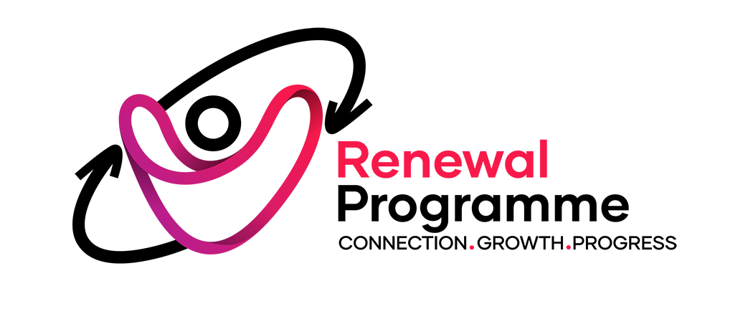

JOB DESCRIPTION

Department: Advice and Support

Job title: Transformation Hub Manager

Working Hours: 36 hours per week

Rate of pay: £40,940 p/a

Contract: 4-year fixed term, funded by the National Lottery Community Fund.

Reports to: Director of Support & Empowerment

Responsible for: Food Sustainability Project Coordinator, Community Hub Co-ordinator, Warm Welcome Host, Sessional Staff, Project Volunteers.

Location: Mainly our head office in E12, but also in other venues around the borough of Newham as directed.

About the Renewal Programme
For over five decades, the Renewal Programme has been a trusted cornerstone of the community in the London Borough of Newham, tackling the root causes and consequences of poverty, isolation, and disadvantage. We are a well-established and respected local charity dedicated to empowering individuals and communities to reach their full potential. Our holistic approach integrates a wide range of services, including the management of 42 supported housing beds for people at risk of homelessness, advice and support services, adult education and training, youth services, and immigration advice programs. We work with over 3,500 people annually.

Our work is guided by a clear vision of vibrant and integrated Newham communities where everyone has access to suitable jobs, homes, health, and education. We stand alongside those who struggle, inspiring hope and offering opportunities for connection, growth, and progress. This mission is underpinned by our four core values, which are embedded in every aspect of our work:

DIGNITY: Treating everyone with kindness and respect.
INCLUSION: A community where everyone belongs.
COLLABORATION: Working together to achieve more.
EMPOWERMENT: Co-creating opportunities for positive change.

Role overview
The Transformation Hub Manager will play a pivotal role in reshaping our service offerings by creating a vibrant, inclusive, and strengths-based hub for our communities - many of who are underserved, including asylum seekers, refugees, residents facing isolation, and those affected by homelessness. You will lead on the delivery and successful management of our National Lottery funded RenewALL Hub, transforming our ideas from concept into a sustainable, impactful centre for community wellbeing. Central to this role is continuing to drive the shift from a crisis-led service model to a holistic, strengths-based approach, ensuring the RenewALL hub empowers Newham residents to connect, grow, and thrive. A major part of this transformation will be designing and delivering a wide range of new activities and services - from wellbeing sessions and cultural celebrations to learning opportunities and social connection programmes that will attract new participants, reach under-represented groups, and reflect the diversity of our community. Crucially, the Hub will not just deliver activities for residents but will be co-designed and co-produced with them, embedding lived experience and the voice of the community at its core. Success will depend on your ability to build and lead a coherent, motivated team of staff and volunteers, uniting them behind the shared vision of the Hub. You will work to create a welcoming space that reflects the ambitions of our Open House strategy, where dignity, inclusion, collaboration and empowerment are lived out in every interaction.
Detailed role description

1. Leadership & Hub Development
- Lead a team to ensure the successful implementation of the RenewALL Hub project, as submitted to the National Lottery Community Fund, aligning all activities with our “Open House” strategy and theory of change.
- Champion and embed a strengths-based, “advantaged thinking” culture across all Hub operations, actively shifting the focus from deficits to assets.
- Build and inspire a coherent, motivated team of staff and volunteers, uniting them around a shared vision for transformation.
- Provide strategic leadership across service areas, ensuring the Hub consistently embodies dignity, inclusion, collaboration, and empowerment.
- Develop an entrepreneurial approach, actively exploring and testing potential income-generating models (e.g., community café, social enterprise, monetising the cargo bike delivery service) to ensure long-term sustainability.

2. Programme Design & Community Co-Production
- Oversee the design, delivery, and continuous evaluation of a diverse, inclusive weekly programme of activities, informed by community consultation and resident priorities.
- Manage a portfolio of activities that improve wellbeing, reduce isolation, and build skills — including health & wellbeing sessions, cultural celebrations, social connection groups, and learning opportunities.
- Facilitate and champion the Community Hub Involvement Panel (CHIP), ensuring residents co-produce activities and influence the Hub’s direction, with a pathway to influencing trustee-level decision making.
- Skilfully balance delivery of Lottery-agreed outcomes with authentic responsiveness to evolving community needs, using co-production and dialogue to adapt within the funded framework.

3. Partnership Development
- Build and strengthen partnerships with key stakeholders, including NHS teams, Public Health colleagues and social prescribers, creating integrated wellbeing pathways for Newham residents.
- Maintain and expand relationships with local organisations, agencies, and community groups, ensuring the Hub complements and connects with wider services.
- Collaborate internally and externally to integrate Hub activities with other projects, enabling a holistic approach to community resilience.

4. Community Food & Social Connection
- Provide oversight (via the Food Sustainability Coordinator) for all food-related initiatives, ensuring they align with the Hub’s ethos of dignity, choice, and resilience.
- Direct the strategic transition from over-reliance on a traditional Food Bank to an empowering Food Club model, reinforcing pathways from crisis to independence.
- Support the development of a volunteer-led Community Café as a central space for social connection, volunteering and informal support.
- Champion innovation in food sustainability (e.g., cargo bike food collections and redistribution), ensuring initiatives contribute to community wellbeing and environmental goals while exploring opportunities for social enterprise.

5. Operational Leadership
- Oversee the day-to-day running of the Hub space, ensuring it is safe, welcoming, and open 7 days a week.
- Coordinate and support staff, volunteers, and sessional workers across the Hub, embedding strong safeguarding and trauma-informed practice.
- Support the successful implementation of evening and weekend working among staff and volunteers.
- Ensure seamless integration of different service areas (e.g., food, café, warm meals, wellbeing activities), maintaining high standards of delivery and ethos.

6. Promotion & Outreach
- Work with the marketing team to promote the Hub’s activities widely, ensuring strong engagement from under-represented and vulnerable groups.
- Conduct outreach to engage under represented residents, ensuring activities are culturally inclusive and accessible.
- Promote the vision of the Hub to external partners and stakeholders, raising its profile as a vital community resource.

7. Monitoring, Evaluation & Compliance
- Lead on the monitoring and evaluation requirements of our Lottery bid.
- Use monitoring and evaluation tools (e.g., Upshot) to track engagement, outcomes, and impact, ensuring activities remain effective and relevant.
- Ensure compliance with all necessary regulations, safeguarding, and legal requirements.
- Contribute to fundraising and sustainability by producing monitoring reports, coordinating budgets, and supporting the development of new funding opportunities.

PERSON SPECIFICATION
Essential
Values & Motivation
- Passionate about community empowerment, inclusion, and tackling inequalities.
- Commitment to strengths-based and dignity-first approaches, especially in working with marginalised communities (e.g., refugees, asylum seekers, people experiencing homelessness).
- Alignment with the charity’s values of dignity, inclusion, collaboration, and empowerment.
Skills & Experience
- Significant experience in leading community development or social impact projects.
- Proven track record of designing, delivering, and evaluating community programmes that improve wellbeing and reduce isolation.
- Demonstrable experience of co-production with residents or service users, ensuring their voices shape services.
- Strong partnership-building skills, with the ability to work effectively with statutory services (e.g., NHS, Public Health, Local Authority) and voluntary/community partners.
- Experience of managing staff and volunteers, including supervision, and motivation.
- Strong operational management skills, including overseeing rotas, budgets, and compliance.
- Experience of monitoring and evaluation, including using systems such as Upshot (or similar) to demonstrate impact.
- Knowledge of food sustainability and/or community food initiatives, and ability to oversee related programmes.
- Experience of fundraising or managing grant-funded projects, including reporting to funders and meeting outcome requirements.
- Strong understanding of trauma-informed practice and safeguarding, and ability to embed these across all hub activities.
Personal Qualities
- Excellent communicator, able to engage confidently with diverse communities, stakeholders, and funders.
- Skilled facilitator, able to navigate consultation, co-production, and conflict resolution.
- Entrepreneurial mindset, with the creativity to test new ideas, income-generation models, and social enterprise opportunities.
- Highly organised and adaptable, able to balance many priorities in a fast-paced environment.
- Inspirational leader, able to motivate staff, volunteers, and residents alike.
Desirable
- Experience of managing a community hub or multi-service venue.
- Knowledge of Newham or similarly diverse urban communities.
- Experience in sustainability initiatives, such as low-carbon transport or waste reduction.
- Training or qualifications in community development, leadership, or project management.

